Git Commands

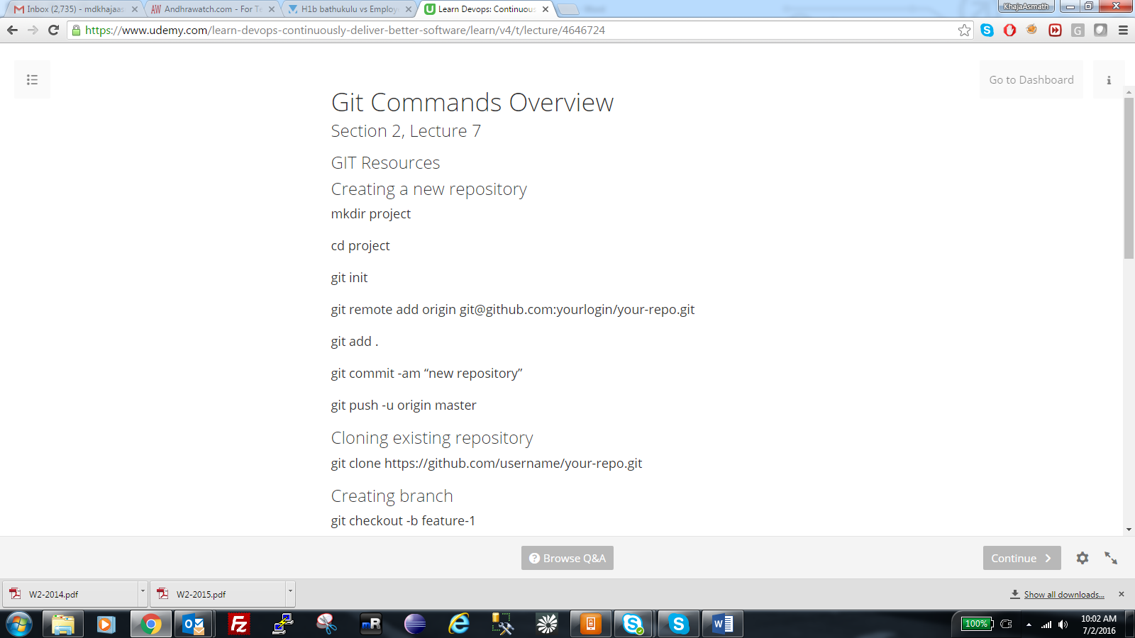

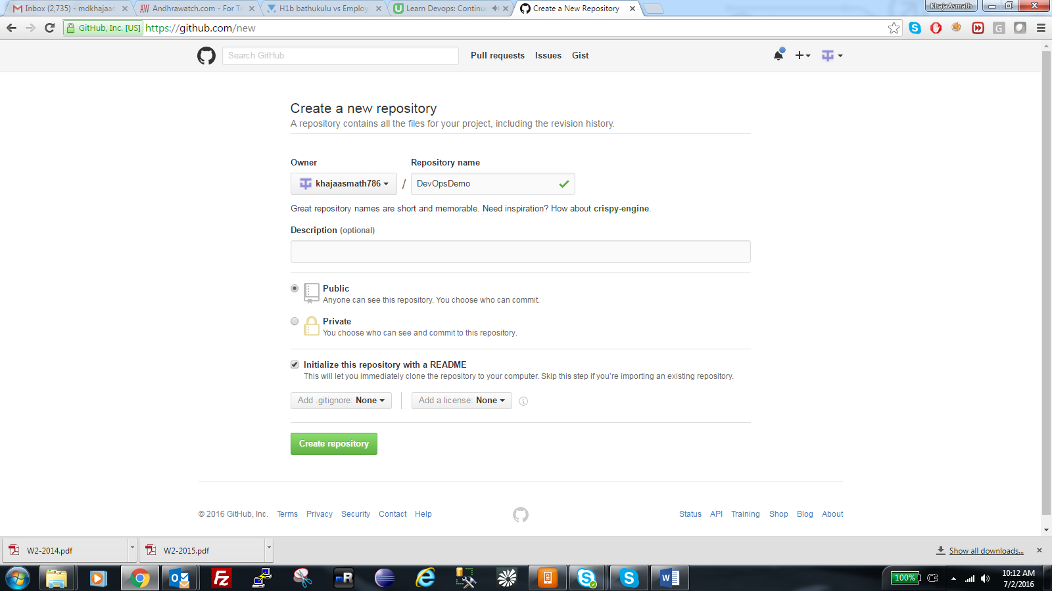

With readme file.

<https://github.com/khajaasmath786/DevOpsDemo>

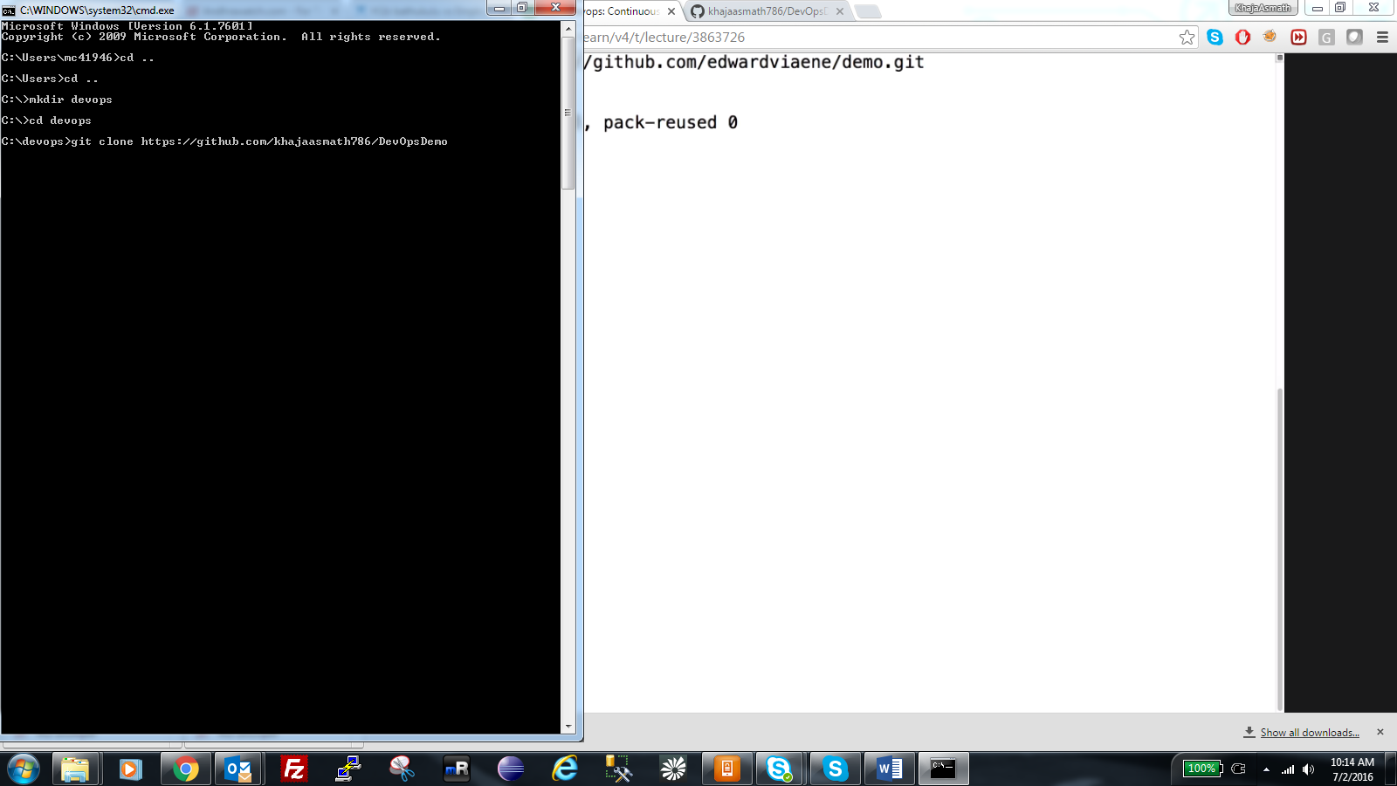

**C:\devops>git clone** [**https://github.com/khajaasmath786/DevOpsDemo**](https://github.com/khajaasmath786/DevOpsDemo)

**Clone the respository.**

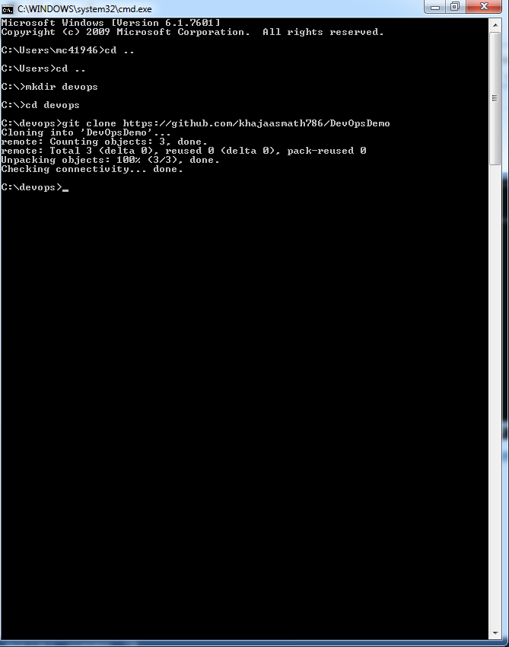

**Add new file into project folder with the below command.**

**C:\devops\DevOpsDemo>echo 'test 123' > text.txt**

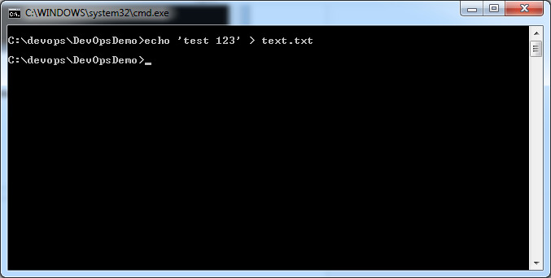

**Add File to GIT Locally:**

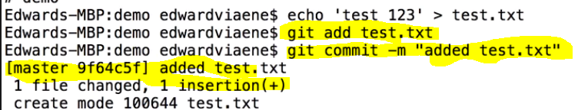

**Commands: git add test.txt, git commit –m “added test.txt. this is comment”**

**Above commands have added the file locally.**

**PUSH the file to central Repository**

**Command: git push**

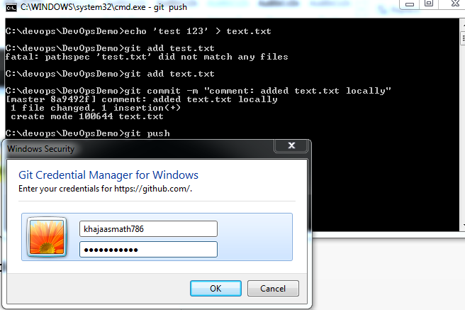

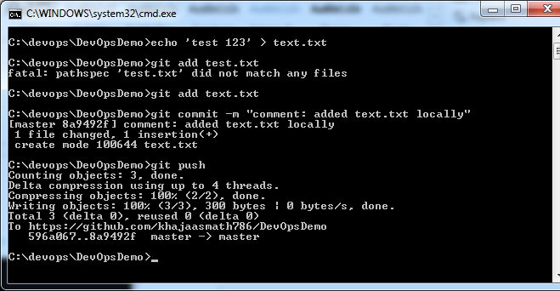

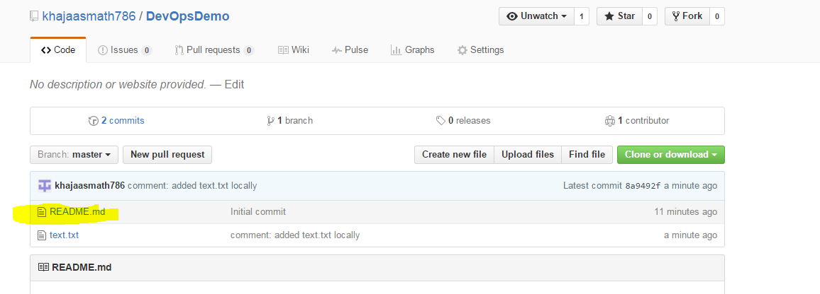

**Create and Switch to New Branch.**

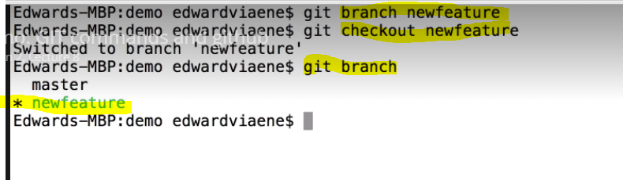

**Commands: git branch newbranchname, git checkout newbranchname ..**

**And git branch will display which branch you are working on.**

**You created branch so you need to checkout to work on that. When checkout you will be defaulted to that branch in workspace.**

**ADD FILES TO NEW BRANCH IN GIT**

**Commands: git add test.txt, git commit –m “added test.txt. this is comment”**

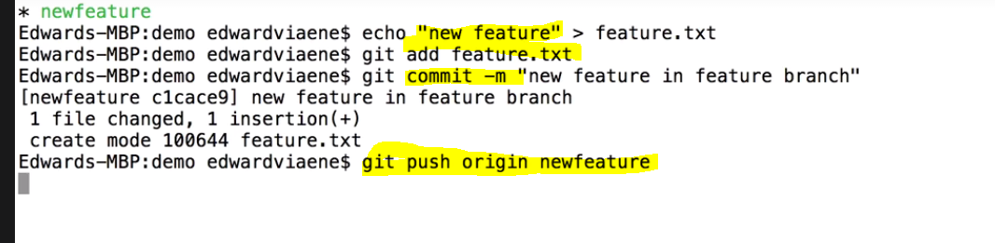

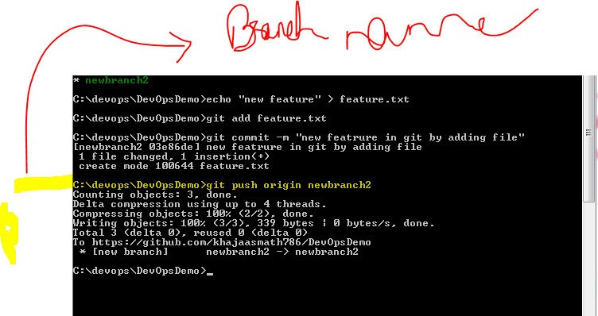

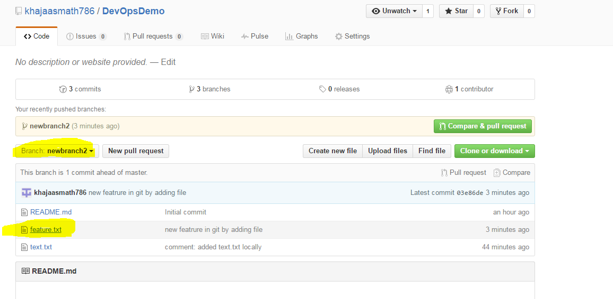

Merge Branch to Central Repository Master:

**Step1:** First checkout master:

**Command:** git checkout master 🡪 this will change your view to master.

**Step2:** Merge the Branch to Master with below command

**Command:** git merge branchname 🡪 in this case git merge newbranch2

**Step3:** Still the merge is done locally so you have to push it to central repository by the below command

Command: git push

**Step4:** check the master after pushing the changes.

